Our Deaf Provision

Roding Primary School has a specialist provision for children who have a severe to profound permanent hearing loss. The provision has 35 places for children from Nursery to Year 6. It is our aim to ensure that all these children become confident and independent with the skills they need to achieve their potential - that they are ‘Free to Achieve’. We recognise that all Deaf children are individuals with their own personality, strengths and needs, and we aim to teach them accordingly. Our children are fully included in all aspects of school life at Roding and both hearing and deaf pupils benefit from working and playing together.

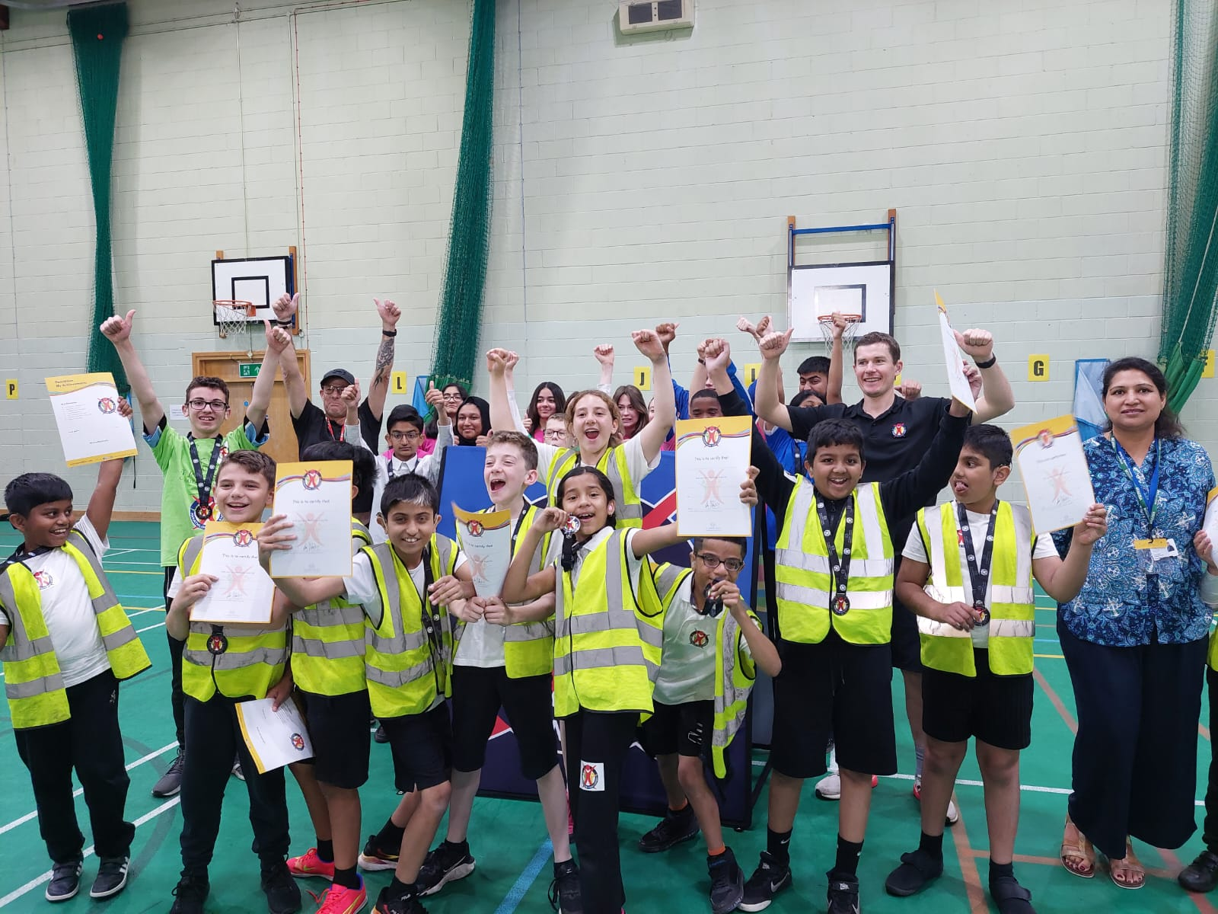

Teaching and Learning
Our Teachers of the Deaf plan alongside the Class Teachers to ensure that all our Deaf children receive the best education for them.
If possible, we always plan to teach our children in their mainstream class. However, if it is more appropriate for them to be taught in a small group with one of our Teachers of the Deaf, they will be taught out of class in one of our soundproofed rooms. Whether taught in or out of class, our Teachers of the Deaf ensure that our children are able to access the school curriculum at the level that is right for them and they are taught the vocabulary to be able to do this. Our children are taught in a practical way using various visual resources to aid their understanding, linking it to real life experiences where possible. We also have a team of Communication Support Workers and Teaching Assistants who support our children with their learning depending on their needs. Children who need sign to help them access the curriculum are supported using Sign Supported English (SSE). We also use visual phonics and additional signs to help the children with their learning and written work.

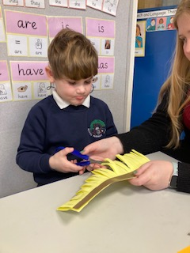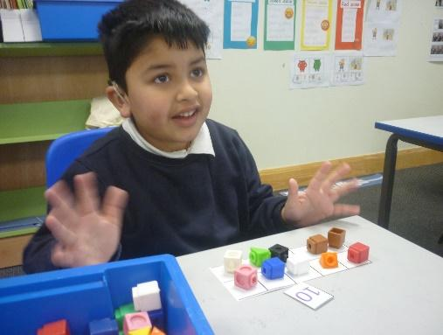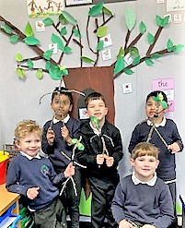

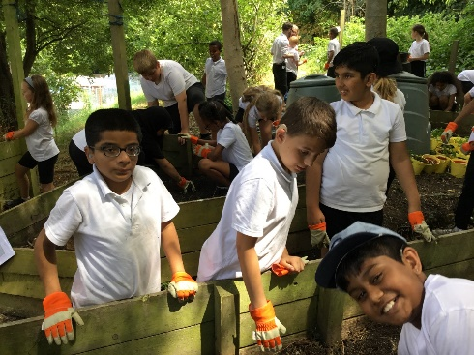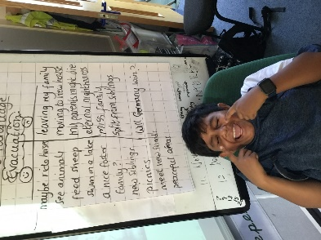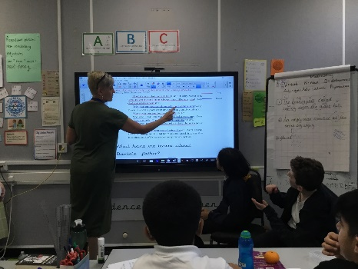

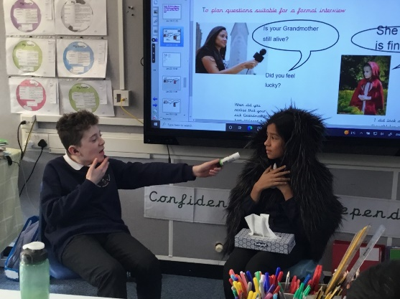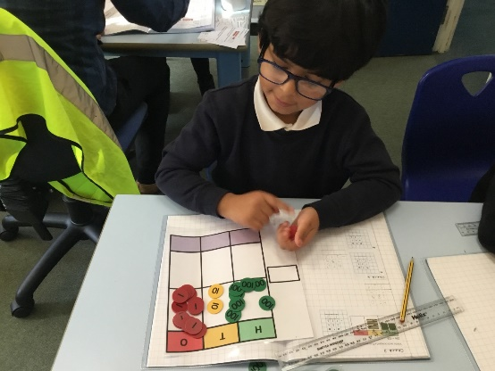

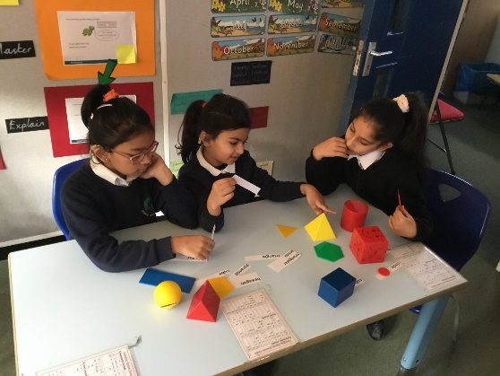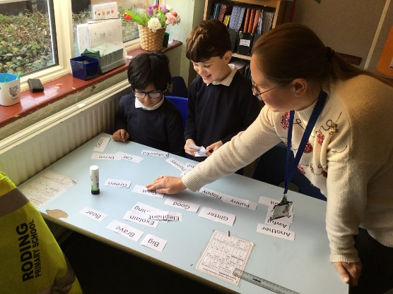

Music Lessons
We are fortunate at Roding to have music lessons for our Deaf children, which are funded by ‘Music of Life’. Our children are currently taught by Ruth Montgomery, who herself is Deaf and plays the Flute. Some of our children receive a weekly music lesson in a small group and some are lucky to receive individual recorder or piano lessons.

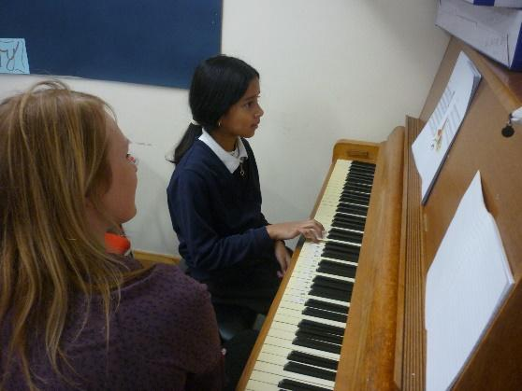

Deaf Identity Lessons
Our Year 4, 5 and 6 children receive weekly Deaf Identity lessons, led by our Communication Support Workers who are also positive Deaf role models for the children. The Deaf Identity lessons give the children an opportunity to discuss PSHE issues from a deaf perspective and give a chance for the children to talk about their deafness and gain a better understanding of it.
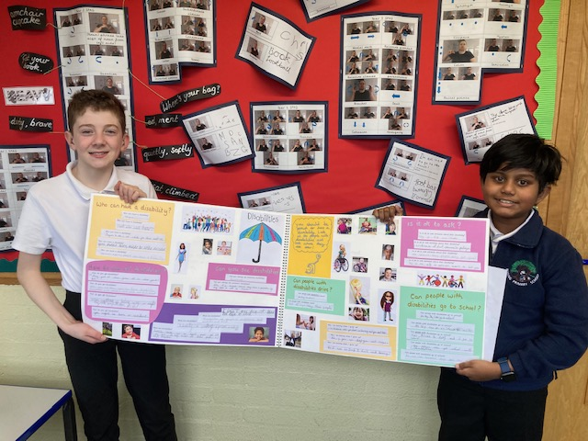

Extra-Curricular Activities
Our pupils have the opportunity to attend all of the school's extra-curricular activities alongside their hearing peers. Some of these take place at lunchtime so that pupils who live a long way from the school can attend. Examples of activities available are multi-sports, singing, chess, football and netball.
We also run a weekly Deaf Club at lunchtime, so that Deaf children from different year groups can meet, play games and socialise with one another.
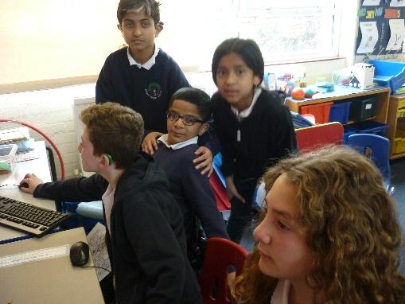

Assessments and Reviews
Every child in our provision has a termly progress meeting where their short-term targets are reviewed and new targets agreed with the parents. If a child does not have an Education Health Care Plan, this will be initiated after attending Roding for one term, it will then be reviewed annually.
Our pupils are assessed using Target Tracker alongside their hearing peers. In addition to this, their writing is assessed using the NDCS Analytical Writing assessment and this is used to set targets for reach child.
Each child is assessed before their annual review so their progress can be closely monitored. A variety of assessments are used according to the child’s age, for example British Picture Vocabulary Scale (BPVS), BOEHM Basic Concepts in Maths and the Test of Non Verbal Intelligence (TONI).
They also receive formal and informal assessments from the Speech and Language Therapist.

Audiology

At Roding we have children with a range of hearing aids, cochlear implants and bone-anchored/bone conduction hearing aids (Bahas)) which are provided by the Health Service. These are checked daily as soon as the children arrive at school and throughout the day as needed. Our children also have access to a radio aid system and all mainstream classes have a soundfield system.

All staff working with our children are trained to do basic daily checks of equipment and we have a trained Audiology Technician who assists as needed to ensure our children have all the equipment they need and it is working.

We teach our children to be independent with their audiology equipment by being actively involved in their daily checks. Children are also encouraged to develop their own strategies to give them access to their own learning e.g. seating in the best place to access lessons, giving the microphone to the speaker, telling the speaker that they cannot hear. We help our children to have a good understanding of their audiogram and how their audiology equipment helps them.

We liaise with a number of audiology and cochlear implant centres, ensuring that they know how the children are progressing in school and also that we know any changes to their hearing levels and changes to their audiology equipment. Any faults with their equipment are reported immediately to parents and where appropriate to the correct audiology clinic.

We carry out Functional hearing tests with each child once a year. More assessments may be carried out where a child is developing their listening skills or if there is a concern about the child’s hearing levels. We use our own Early Listening Development Checklist, the McCormick Toy Test and the Manchester Picture and Word List Test as appropriate for each child’s academic and listening ability. For some of our children these tests will be done to assess their ability to lip-read. Our children are also tested daily using the ‘LING sound’ test.

Communication

A Total Communication Approach
We follow a ‘Total Communication’ approach at Roding, which means we tailor the communication approach for each child to their needs. This can change as they make progress, and it can change when they are in a different environment.
We ensure we develop each child’s listening skills to the full, but we will also use BSL signs to help develop their understanding of speech and language. We find that by enabling children to hook spoken words onto signs we are able to accelerate their progress with spoken speech. We use the ‘Speech Sandwich’ approach with our children to ensure they are developing their listening and/or lip-reading skills.
Speech Sandwich
Say it without sign/clue
Say it with sign/clue
Say it again without sign/clue

Many of our children communicate orally, but require some sign support to help them understand the school curriculum. Other children require a greater level of signing and our Communication Support Workers are able to help them develop their British Sign Language (BSL) skills further and support them in understanding the curriculum through sign.

Signing
Although some children at Roding are taught through an oral approach, all children at Roding, including the hearing children, are positively exposed to sign. All the children receive weekly signing lessons with their class, as it was decided that this should be the additional language taught at Roding. This helps to develop the communication skills between all our children. Children are also taught sign in a fun way, through songs and stories. All our children are proud of their signing abilities and by embracing this; we have helped the confidence of our deaf children grow.
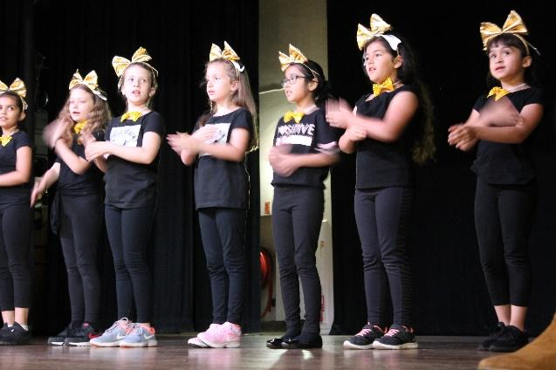

Communication Support Workers
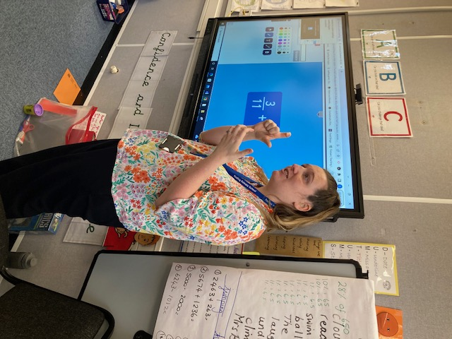We are fortunate to have a team of Communication Support Workers who have Level 3-6 British Sign Language. Their role is fundamentally about access and full inclusion for deaf children to the curriculum and to the social aspects of school. They give a high level of sign support for those pupils who need it to follow class lessons and make assemblies accessible. They support our deaf children by ensuring they can communicate with all their peers, by developing Deaf Awareness in the school and providing signing skills to both deaf and hearing children. They support our lunchtime staff and adults running school clubs to facilitate the communication and inclusion of our deaf pupils.

Speech and Language Therapy
Speech and Language Therapy is provided for the children as stated on their Education Health Care Plan by the Redbridge Speech and Language Therapy Team. We work closely with the speech and language therapist to support the language development of each child. Sessions focus on language learning for functional purposes as well as to enable access to the curriculum.
Students are assessed formally and informally to measure their progress and to set new targets. Their targets are set and reviewed termly and these are shared with each student’s family to support their progress at home.
Staff working with the children on a daily basis attend Speech and Language Therapy sessions with students to support carry over of skills learnt and language programmes are provided on an individual basis for Teaching Assistants or Communication Support Workers to carry out with the children.

Deaf Awareness

At Roding, all staff are trained in basic Deaf Awareness. All teachers and Teaching Assistants have attended training sessions where they have learnt about deaf awareness and how they can best support deaf children with their education, communication and social needs. All staff are aware of our Top Tips for supporting deaf children and follow these to ensure our children get the best support.

Deaf Role Models
We have three members of staff at Roding Primary who are deaf and are excellent role models for our children.
We also invite successful deaf adults to come into school during our Deaf Awareness Week to work with both our deaf and hearing children. This has proved very successful in promoting a positive image of deaf people and for increasing the self-esteem of our deaf children.
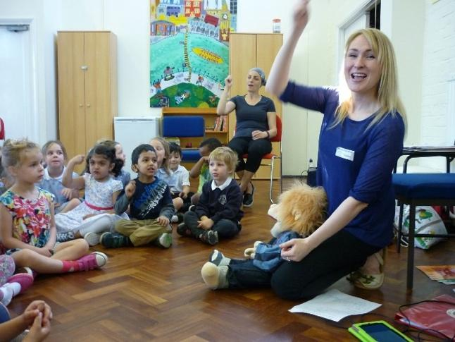
Ruth Montgomery plays the Flute. She has visited us on a number of occasions to teach all our children music and perform to them. She always has different ideas to engage our children and it is amazing to see how much they learn from these sessions. She now teaches our deaf children weekly.

Chris Fonseca is a famous deaf dancer. He has visited our school and talked to our children about how hard he worked to achieve his big dream. Our children have been lucky enough to join in with a Dance Workshop led by him.

Deaf Awareness Week
Every year in the summer term we have a very successful Deaf Awareness Week. Each class has a Deaf Friendly book to use with their children to help develop their Deaf Awareness. Classes have also researched Deaf famous people and taken part in the NDCS Fingerspellathon. We have visitors coming to the school to teach about Deaf Awareness and promote a positive image of deaf people. In the past we have had the NDCS, Handprint Theatre, Deaf Men Dancing, Krazy Kats, Ruth Montgomery (Flutist), Eloise Garland (violinist), Jack Harding (footballer) and Chris Fonseca (Dancer). Handprint Theatre has put on several plays to all our children at Roding, entertaining them and raising the profile of signing and Deaf identity at the same time. They have also run drama workshops.
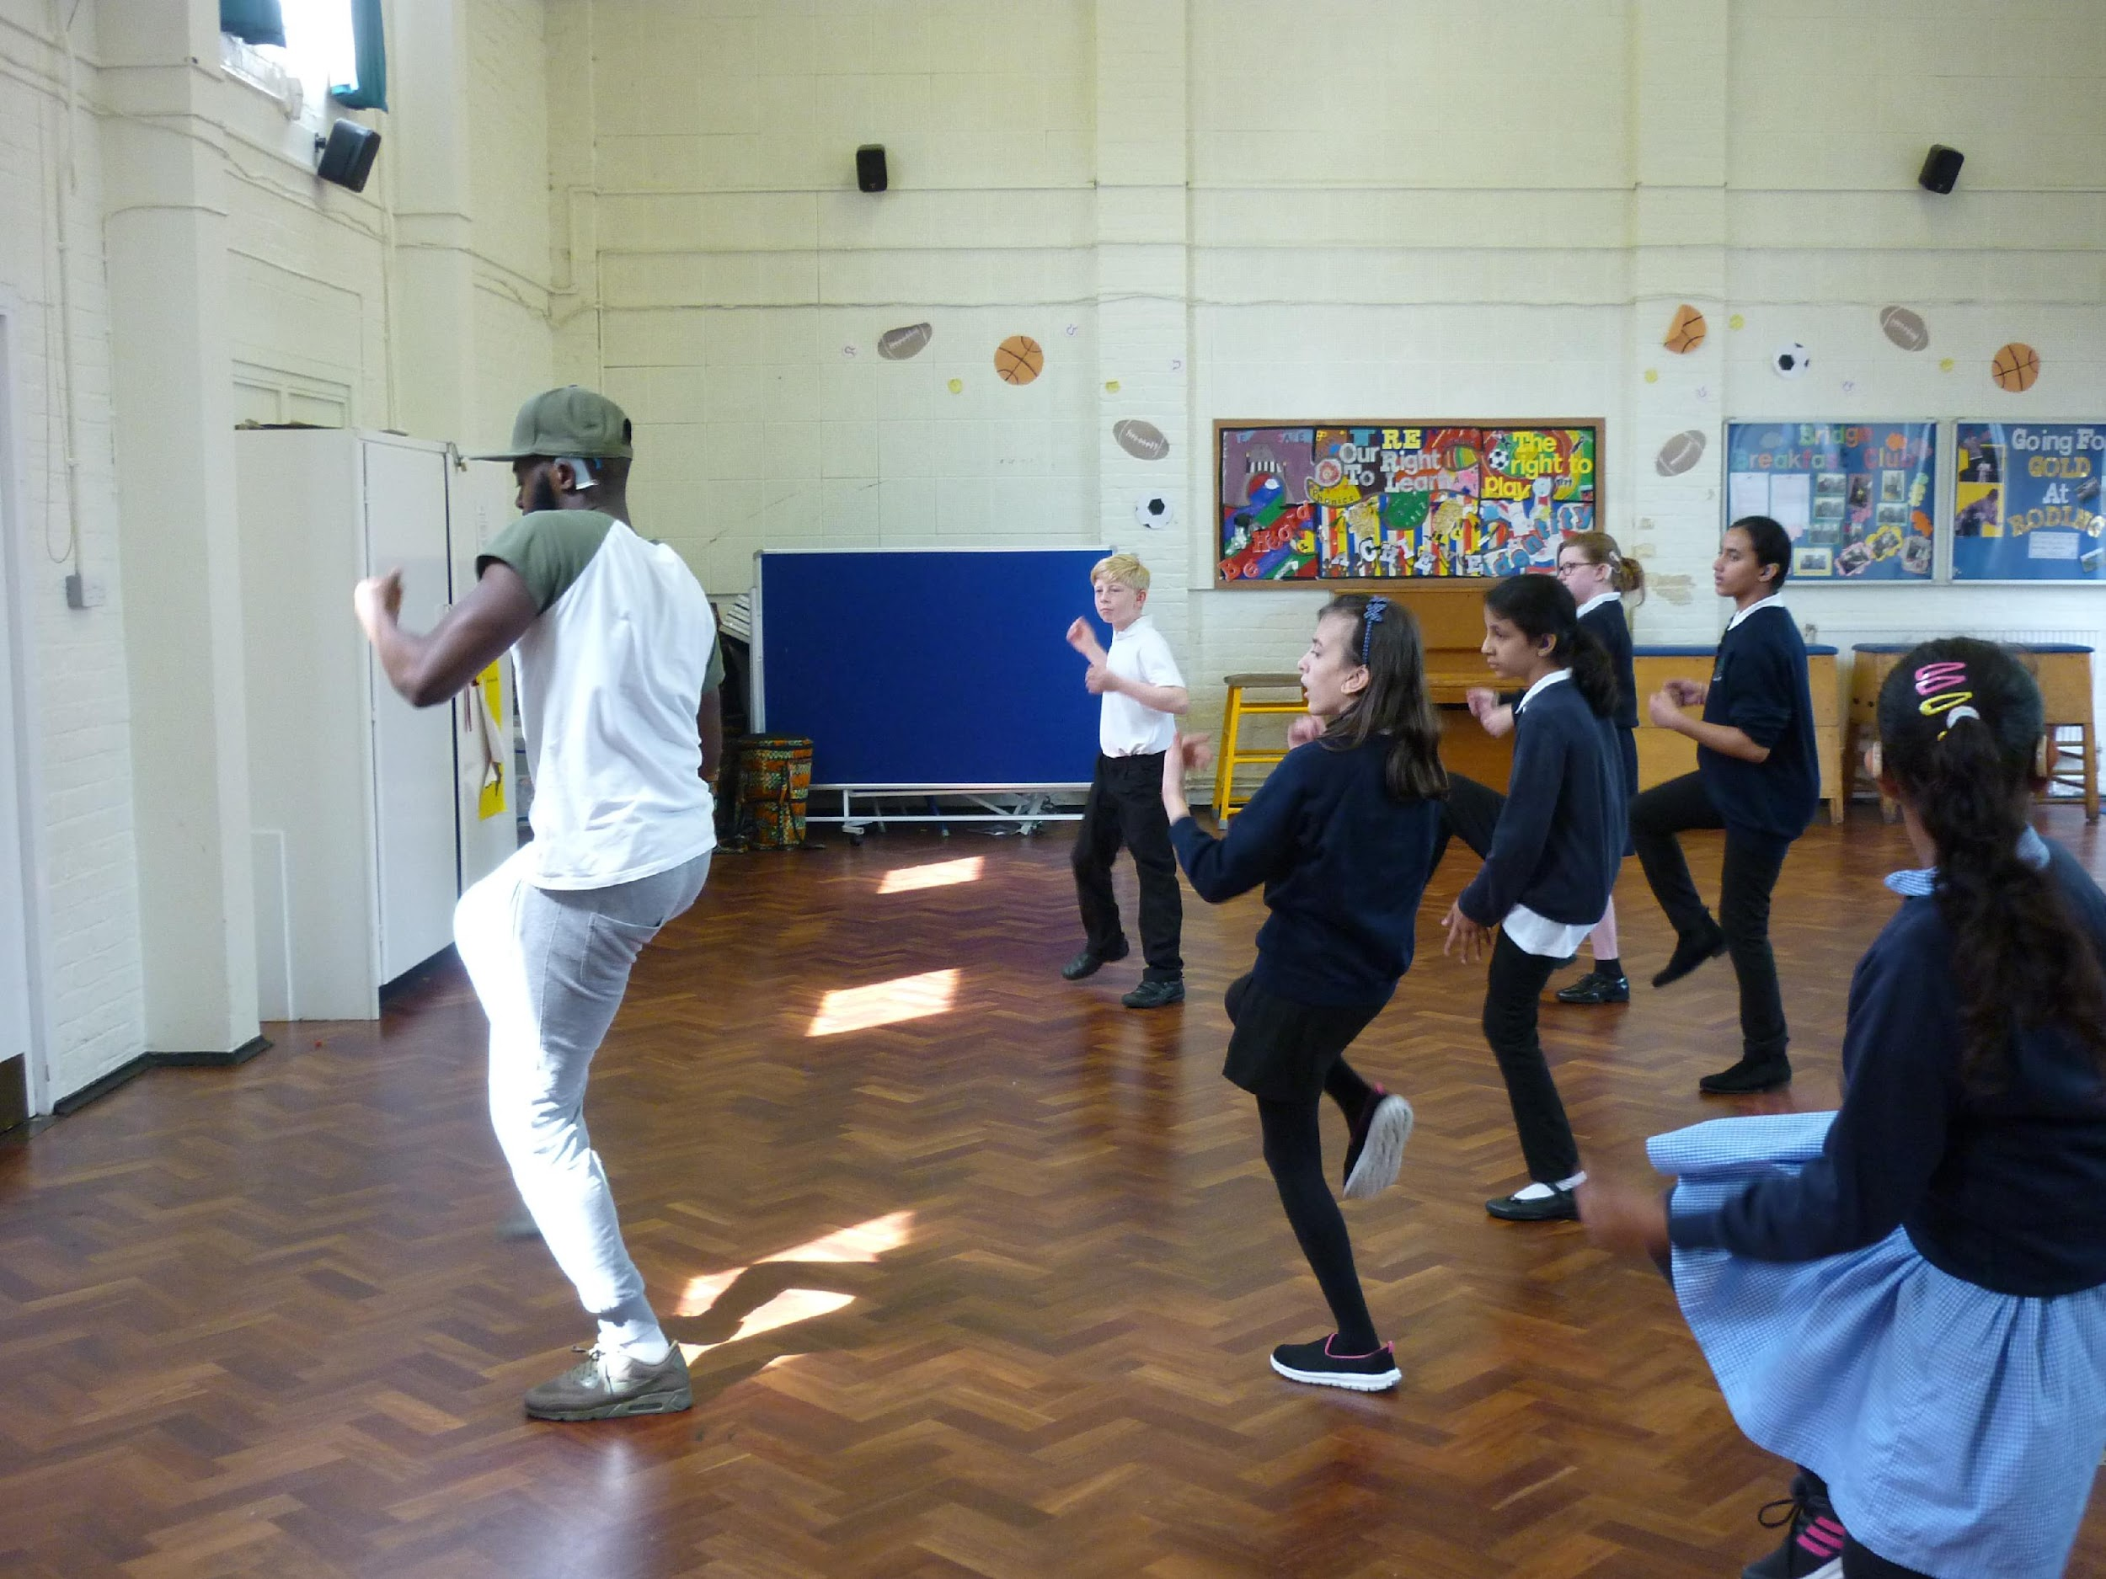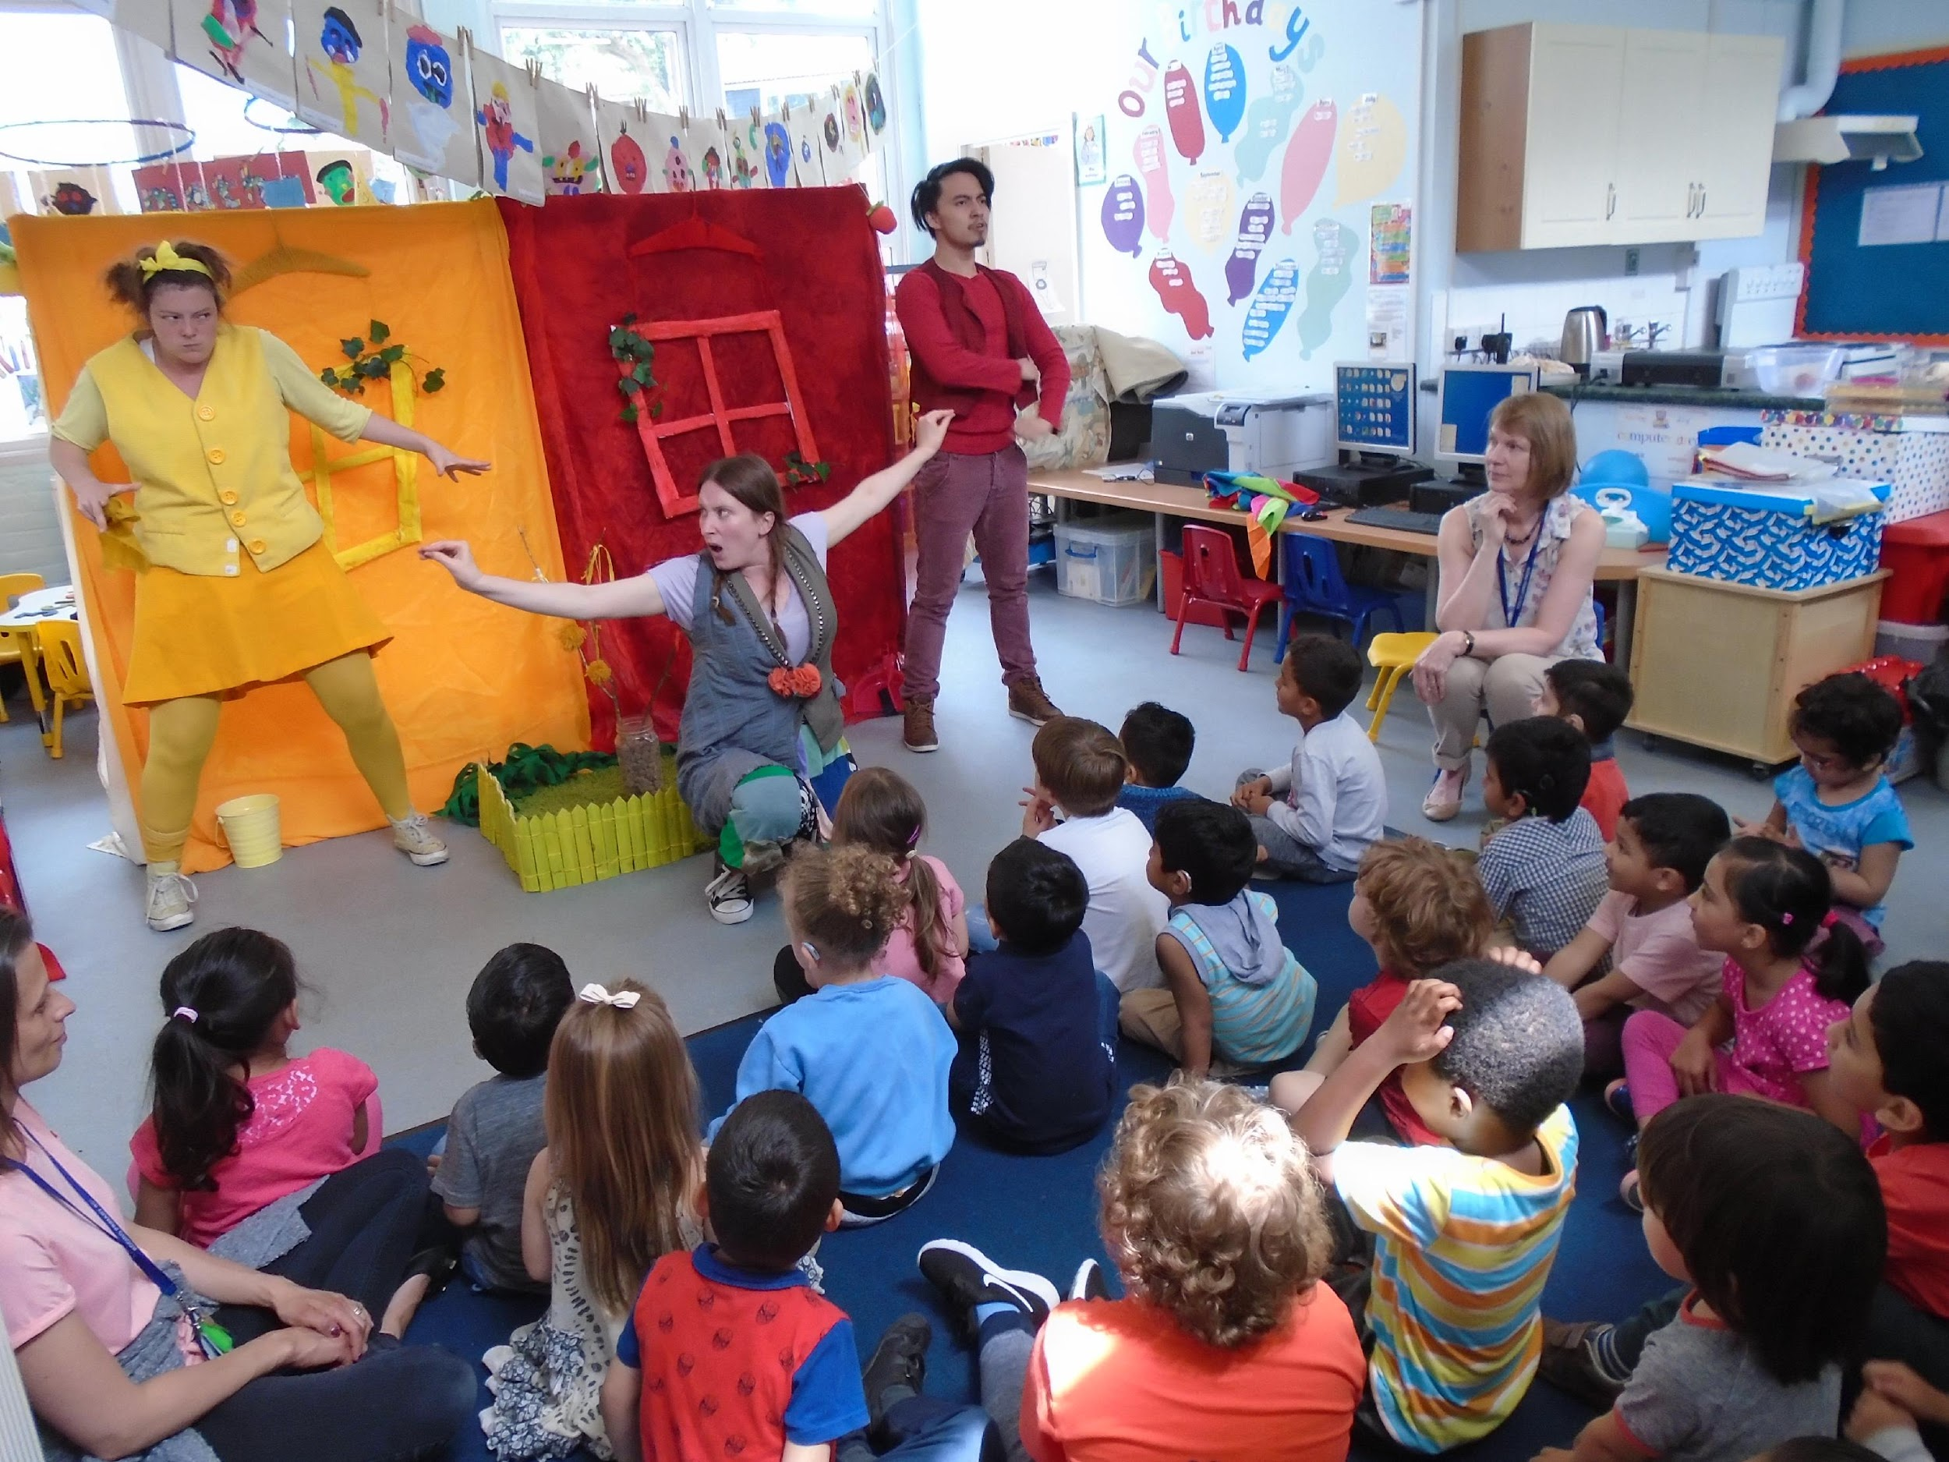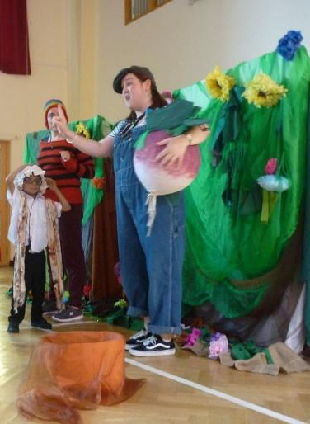

Deaf Events

Go Live Theatre
In 2016, 2018, 2022 and 2023, Years 4, 5 and 6 had the opportunity to work with Go Live Theatre. First, they had the opportunity to go to the theatre to see a play. They then had a number of drama workshops, which led to a play being written. This was acted out by real actors at a theatre in London, which they went to watch. It is a fantastic experience for them all.

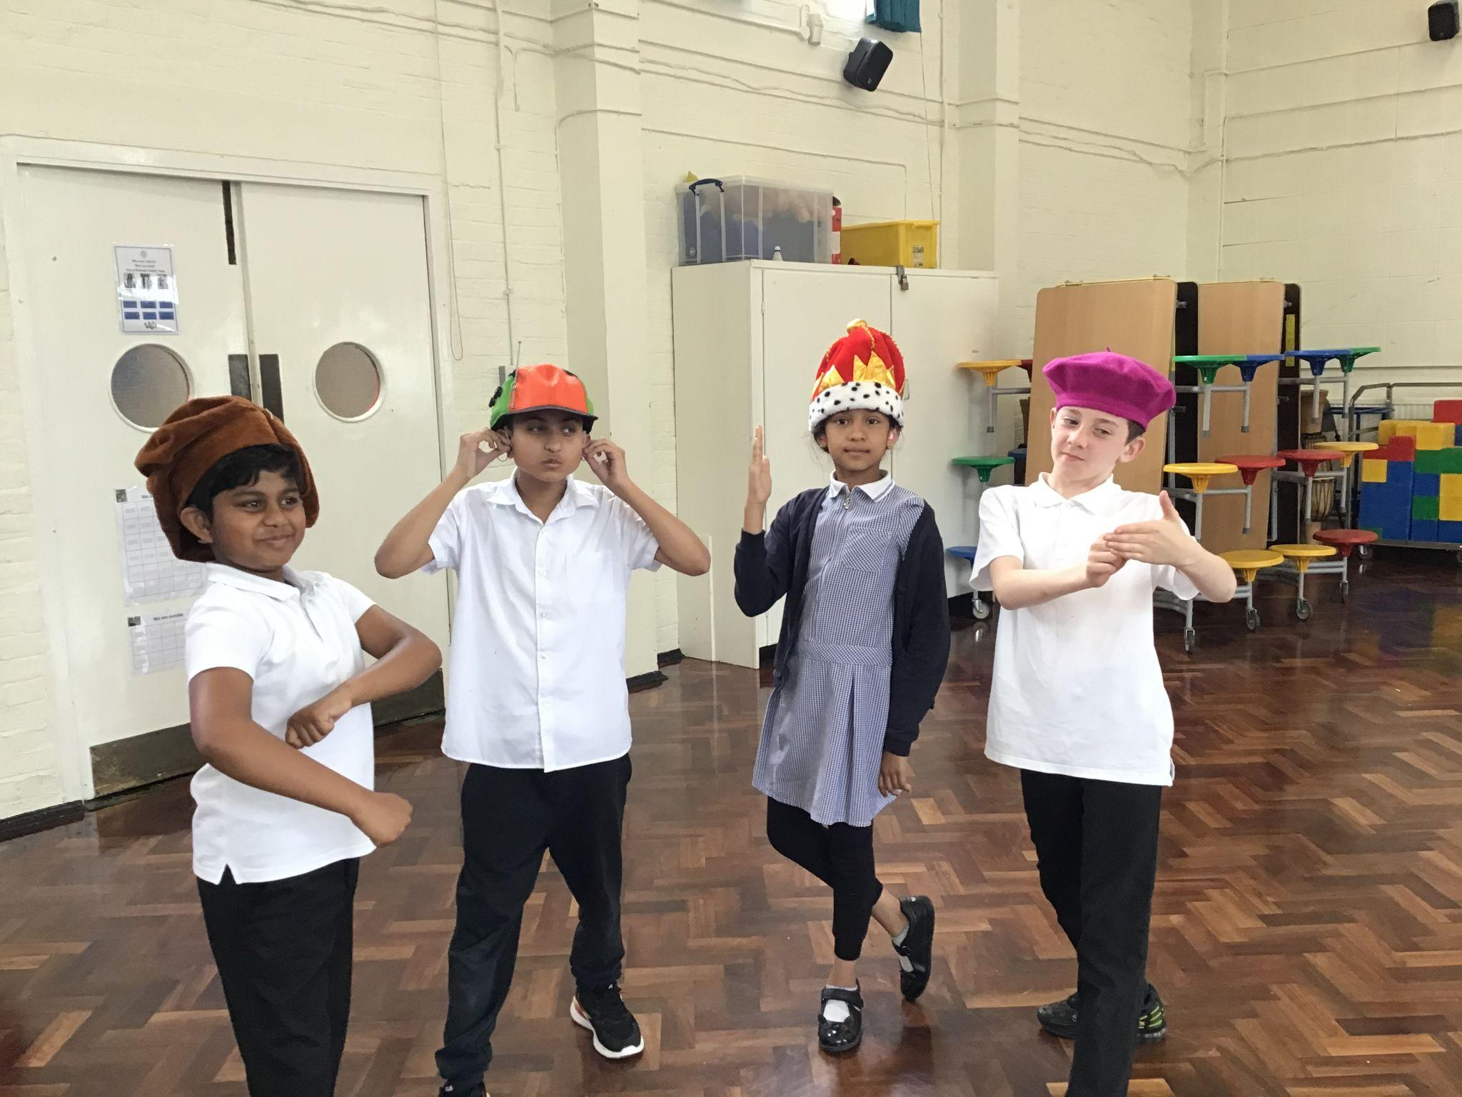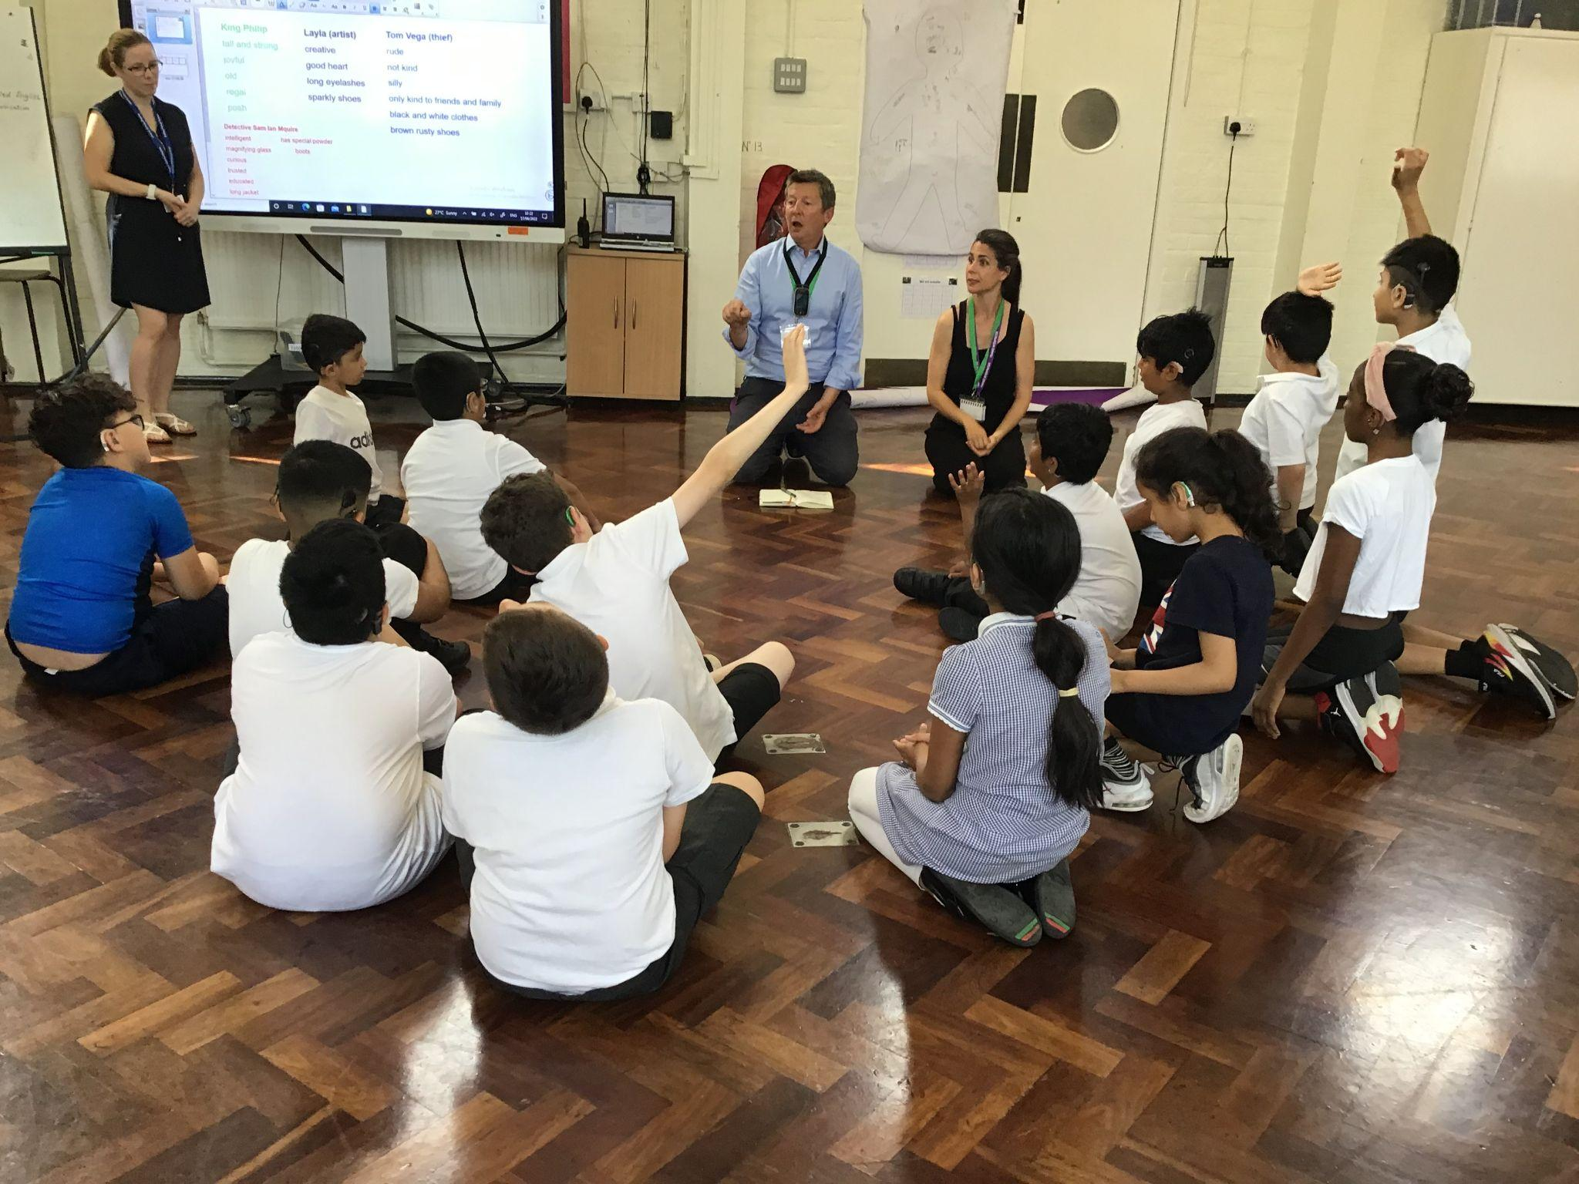

Linking up with other Schools
We regularly attend events at other Deaf Schools so that our children have the opportunity to meet other Deaf children. We have attended events at Warren Primary School, Frank Barnes, Caterham High School and Heathcote Secondary. Our children have also attended NelDeaf Keep in Touch days where they had the opportunity to try out different sports.
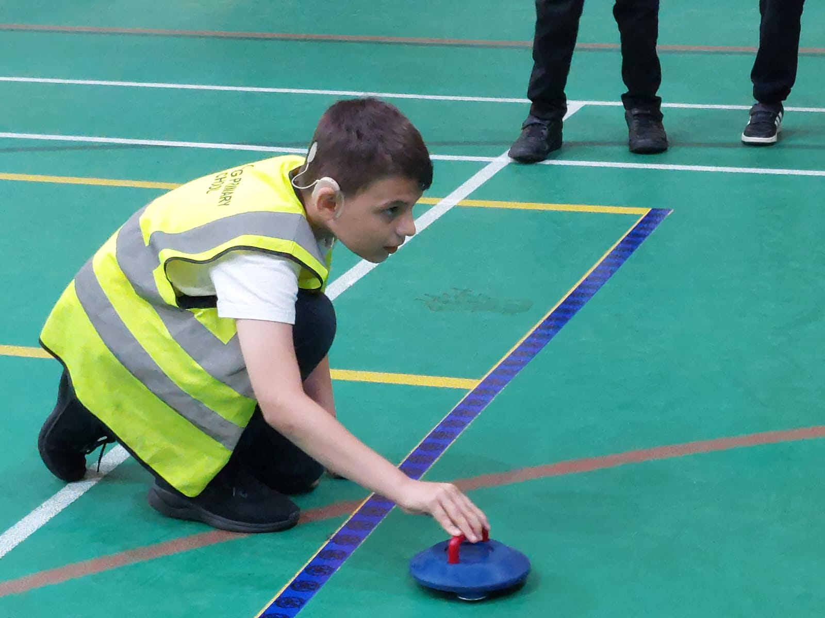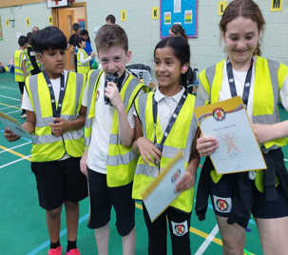

Chris Bolton Memorial Award
In July 2022 we won the Chris Bolton Memorial Award for the positive impact our Deaf Club has on the mental health and lives of our young Deaf children. As our reward, we were given some money to make the children smile. We decided to take them to Paradise Park Zoo. They had a wonderful time and certainly did smile.
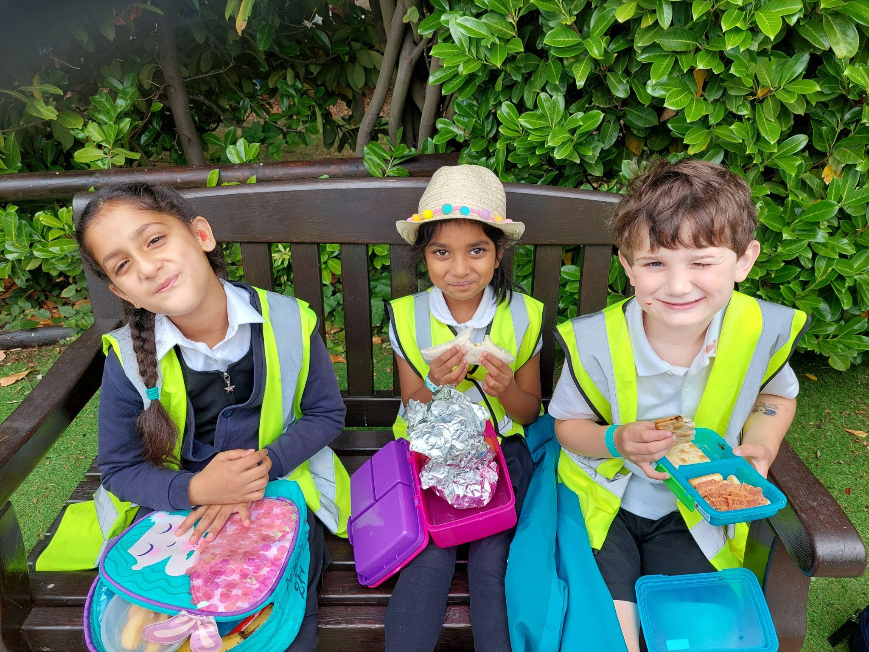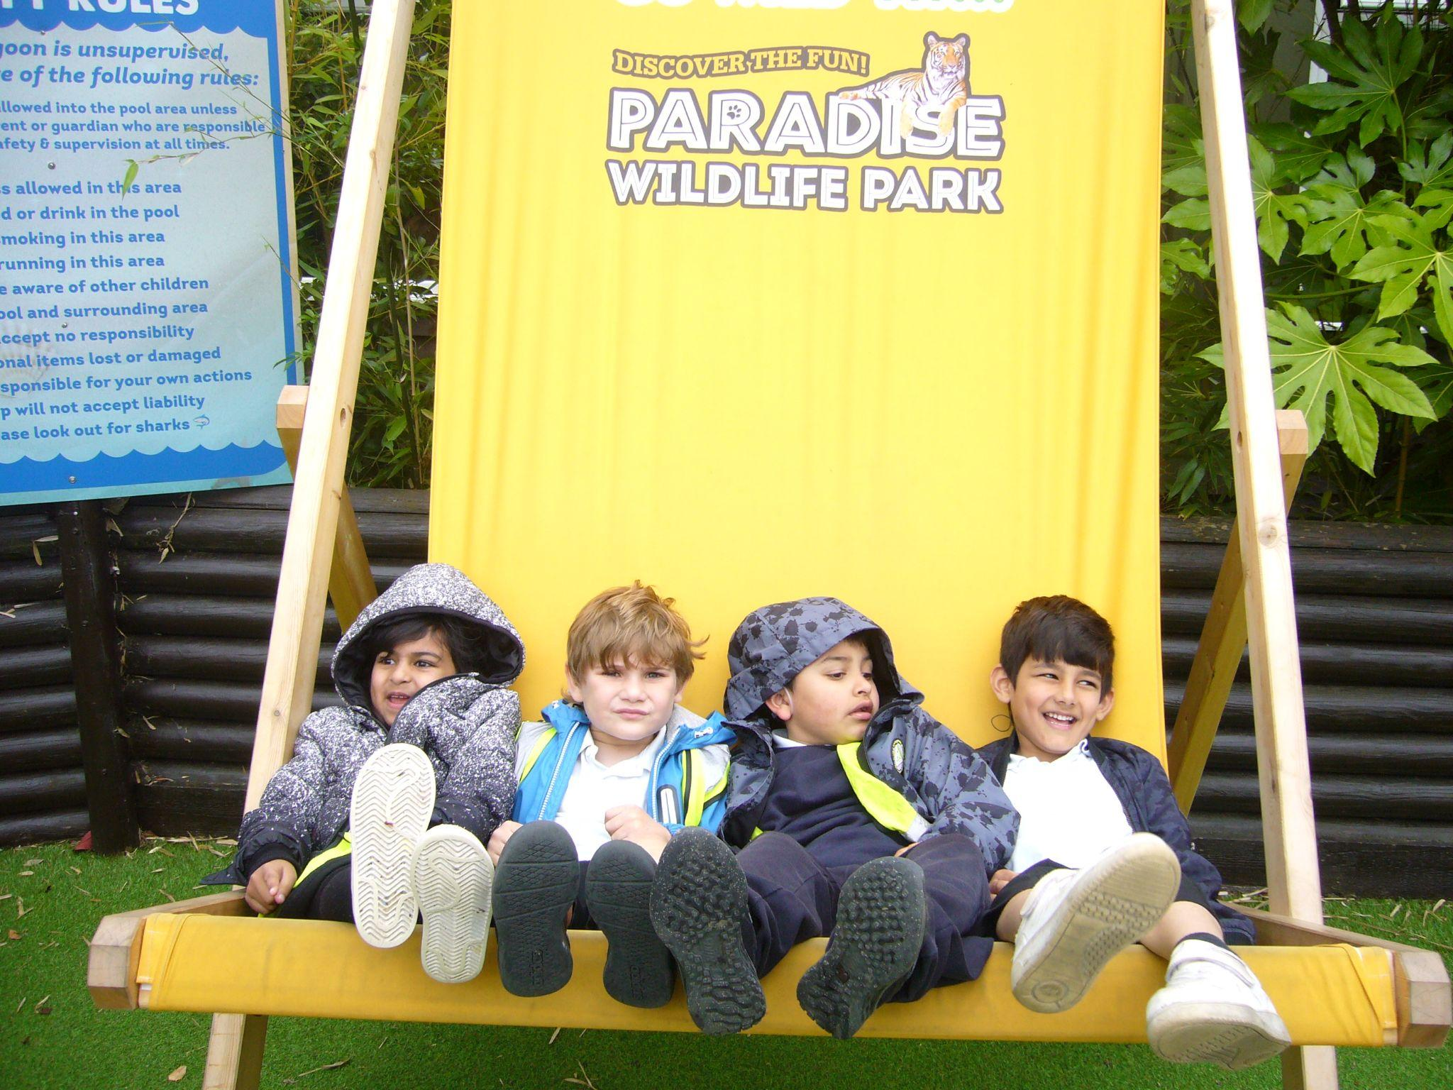
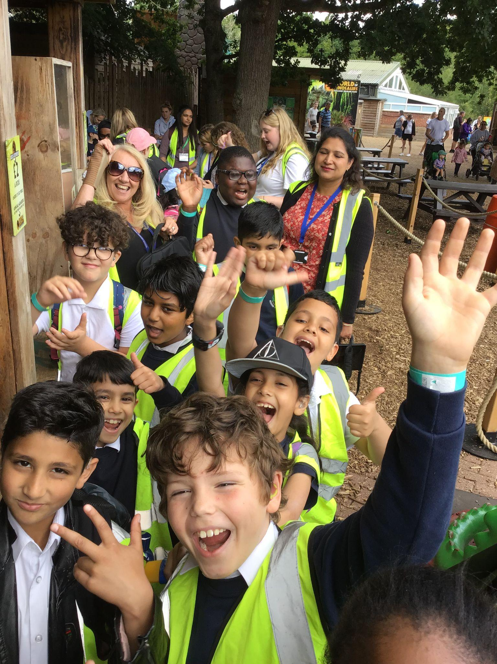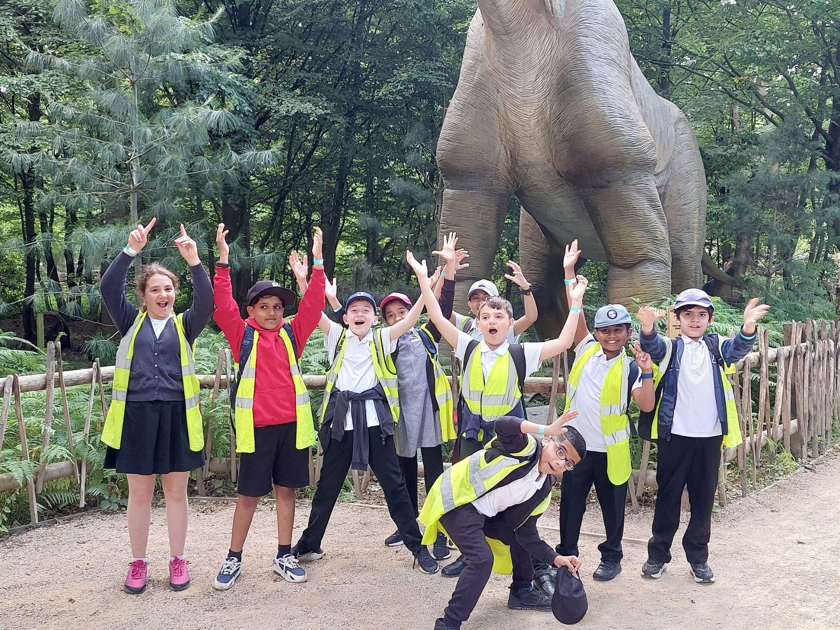

The NDCS
The NDCS Roadshow bus has visited us on a number of occasions. They have given Deaf Awareness training to our hearing children. Our deaf children have had the opportunity to try out different technology to help them and their parents have been able to learn more about how this technology helps their children. The NDCS have also talked to our parents about other ways they can support them and their children.
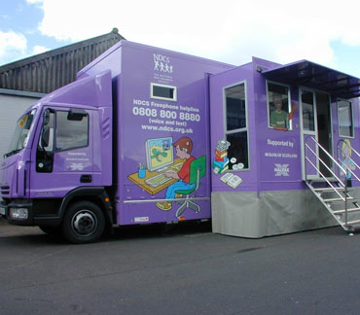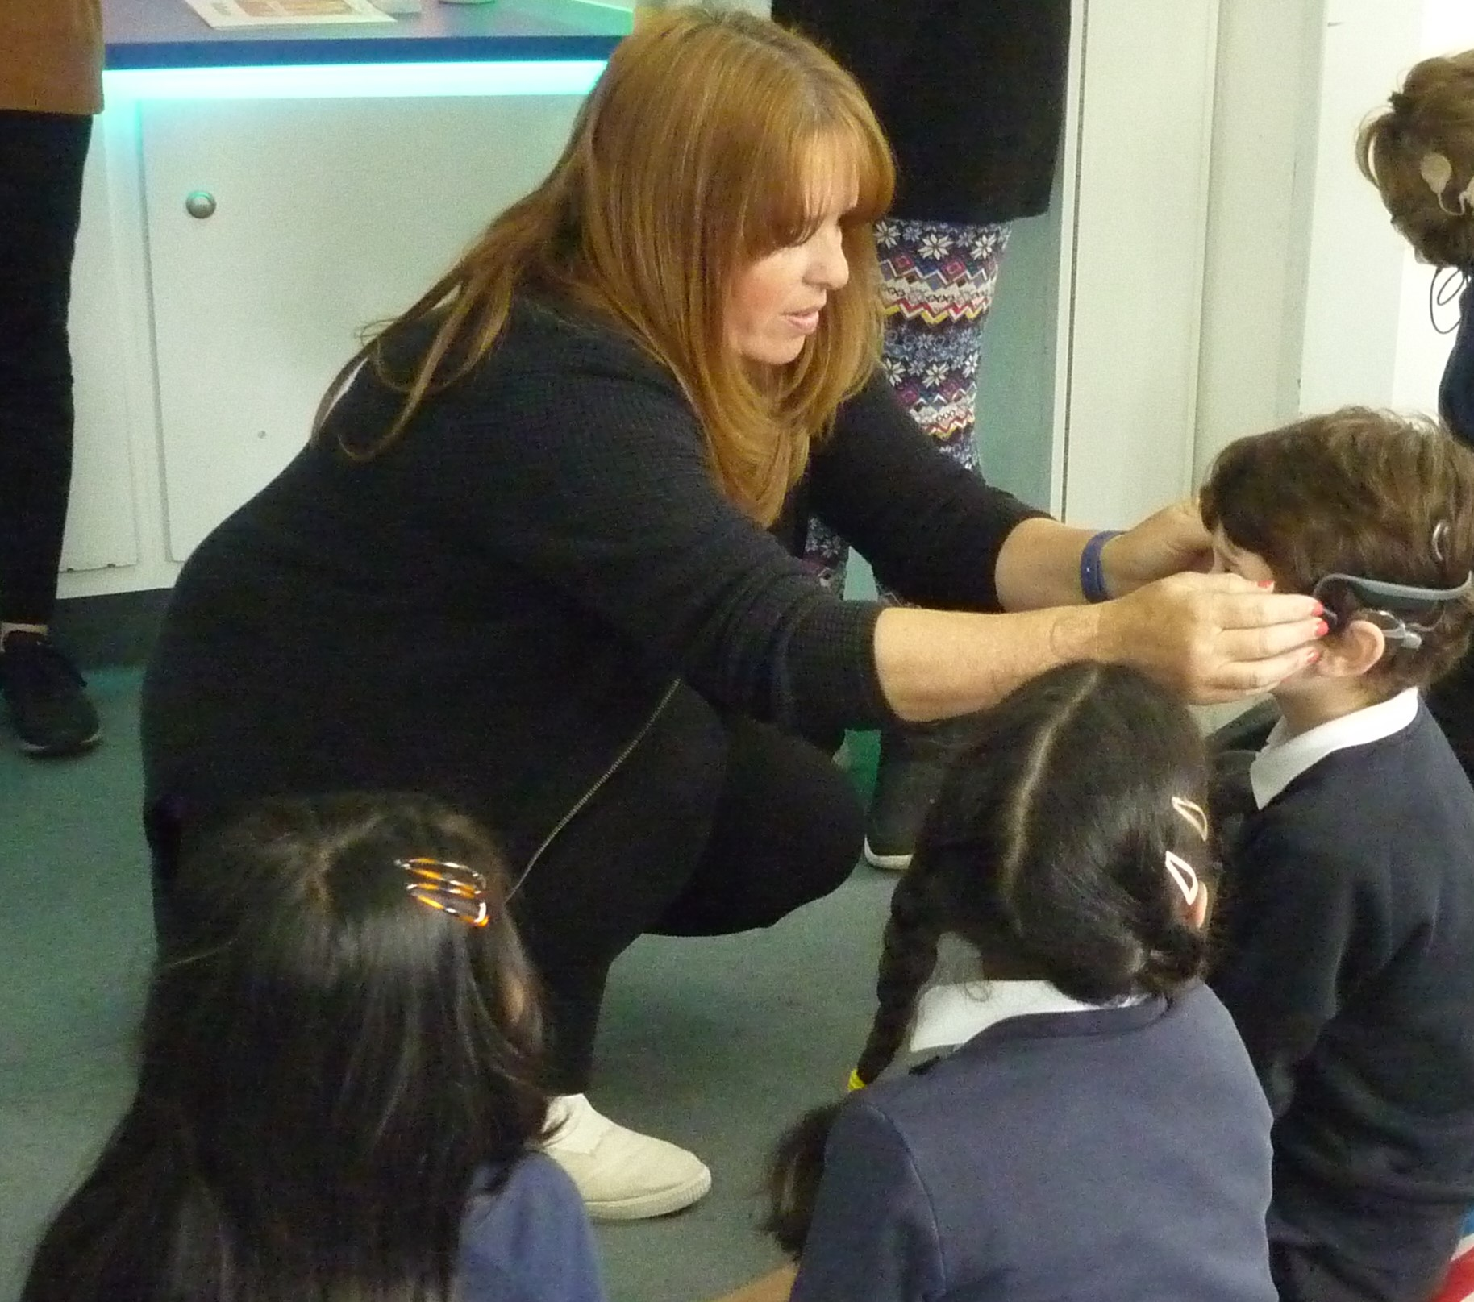

Supporting Deaf Charities
We have taken part in the National Deaf Children’s Society Fingerspellathon twice to raise money to support them with the good work they do. Our children all had a list of words they had to learn to fingerspell. They then had a race to see which team could fingerspell all the words the fastest. It was great fun.
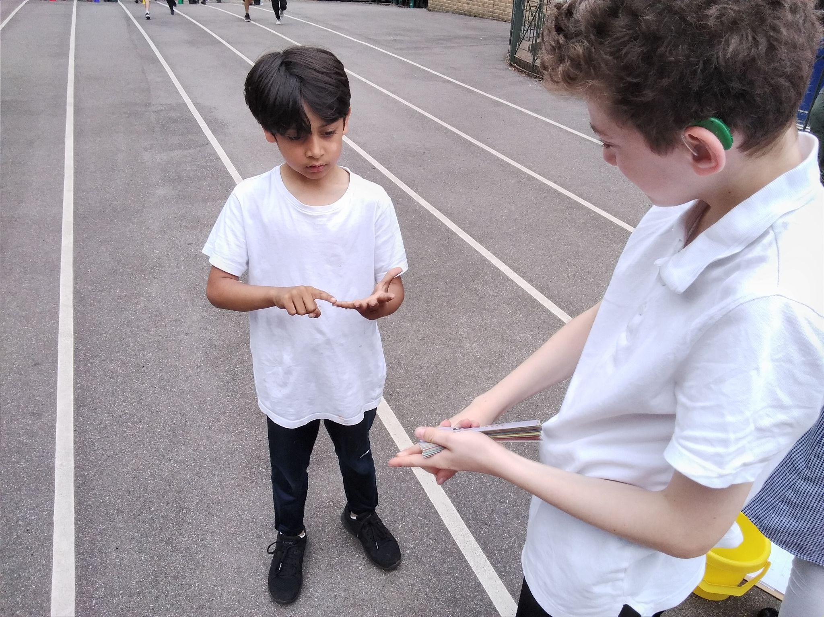
We also raised money for the ‘Empowering Deaf Society’ in 2020 as part of our Christmas jumper day.
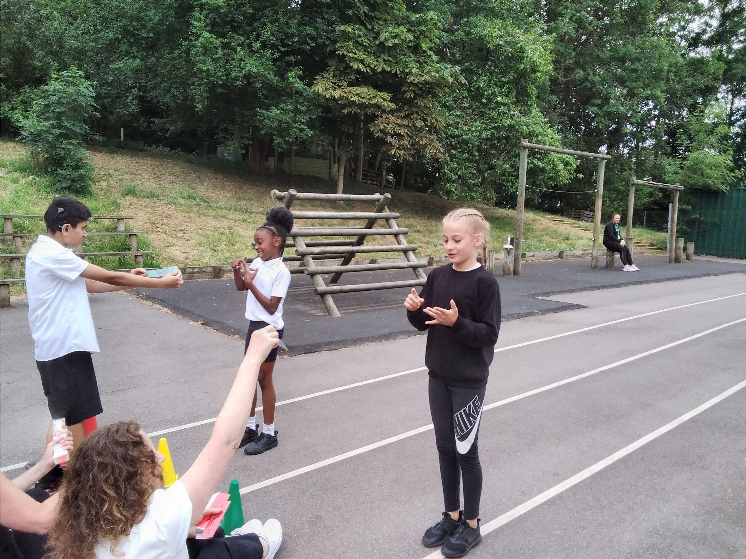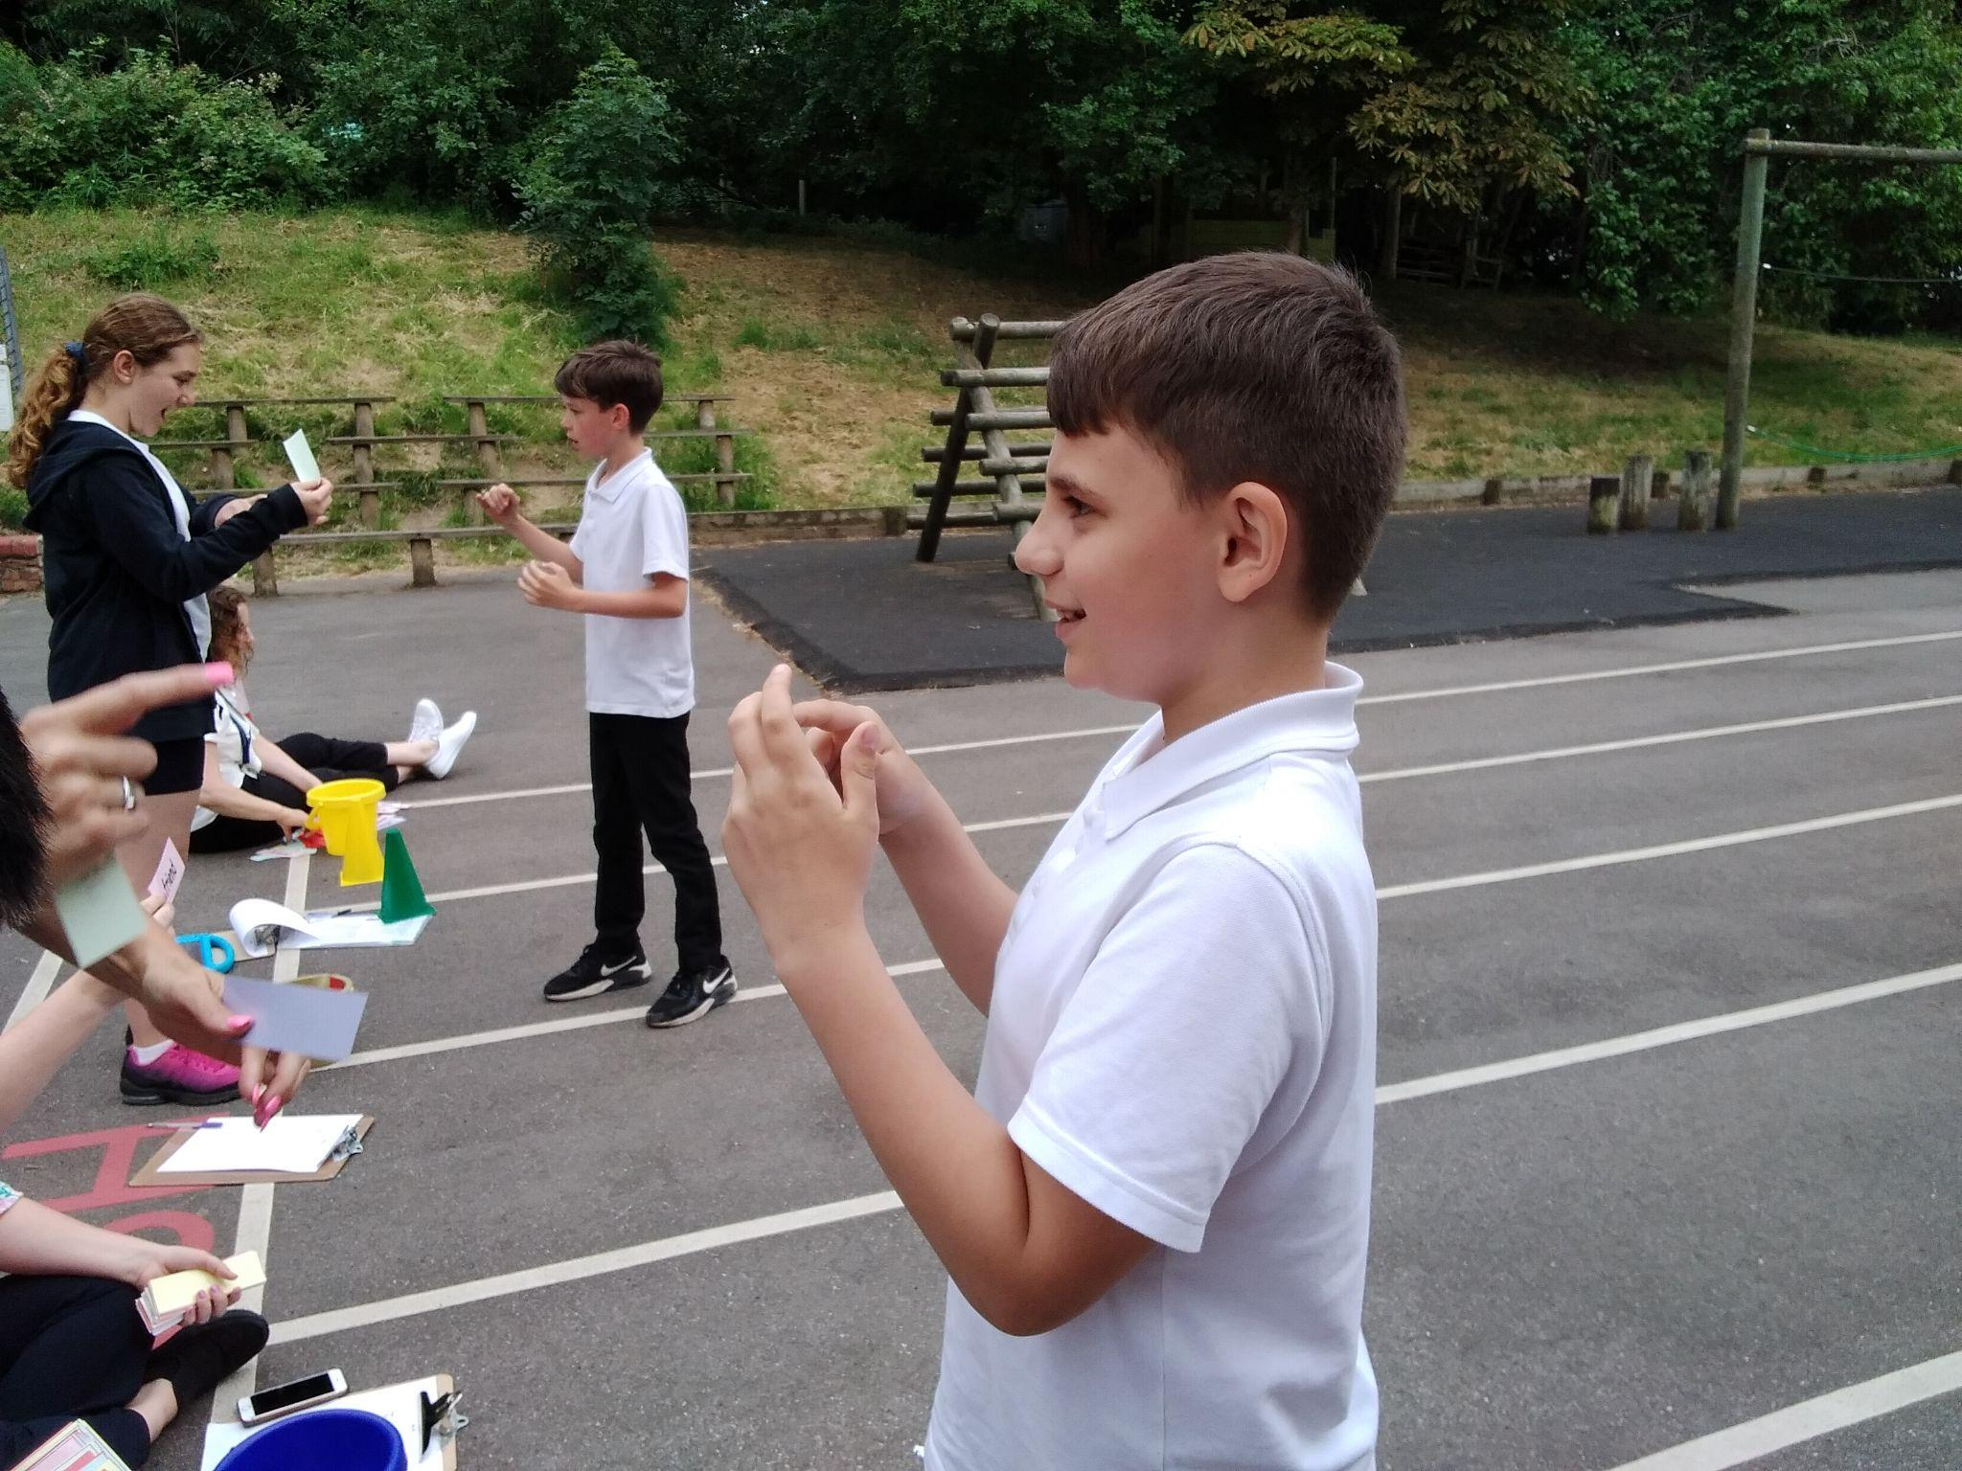

Strictly Come Signing
Roding Primary helped to organise the Local Authority’s ‘Strictly Come Signing’ competition in July 2019 held at the Hawkey Hall. Schools from across the borough were invited to compete. Their choirs had to perform a song using sign. Children competed in four age bands, Pre-school, Key stage one, Key stage two and Secondary. The winning choirs got the opportunity to perform their song on stage at the Hawkey Hall. The event was hosted by Wayne Barrow, who runs his own academy for teaching sign through music.
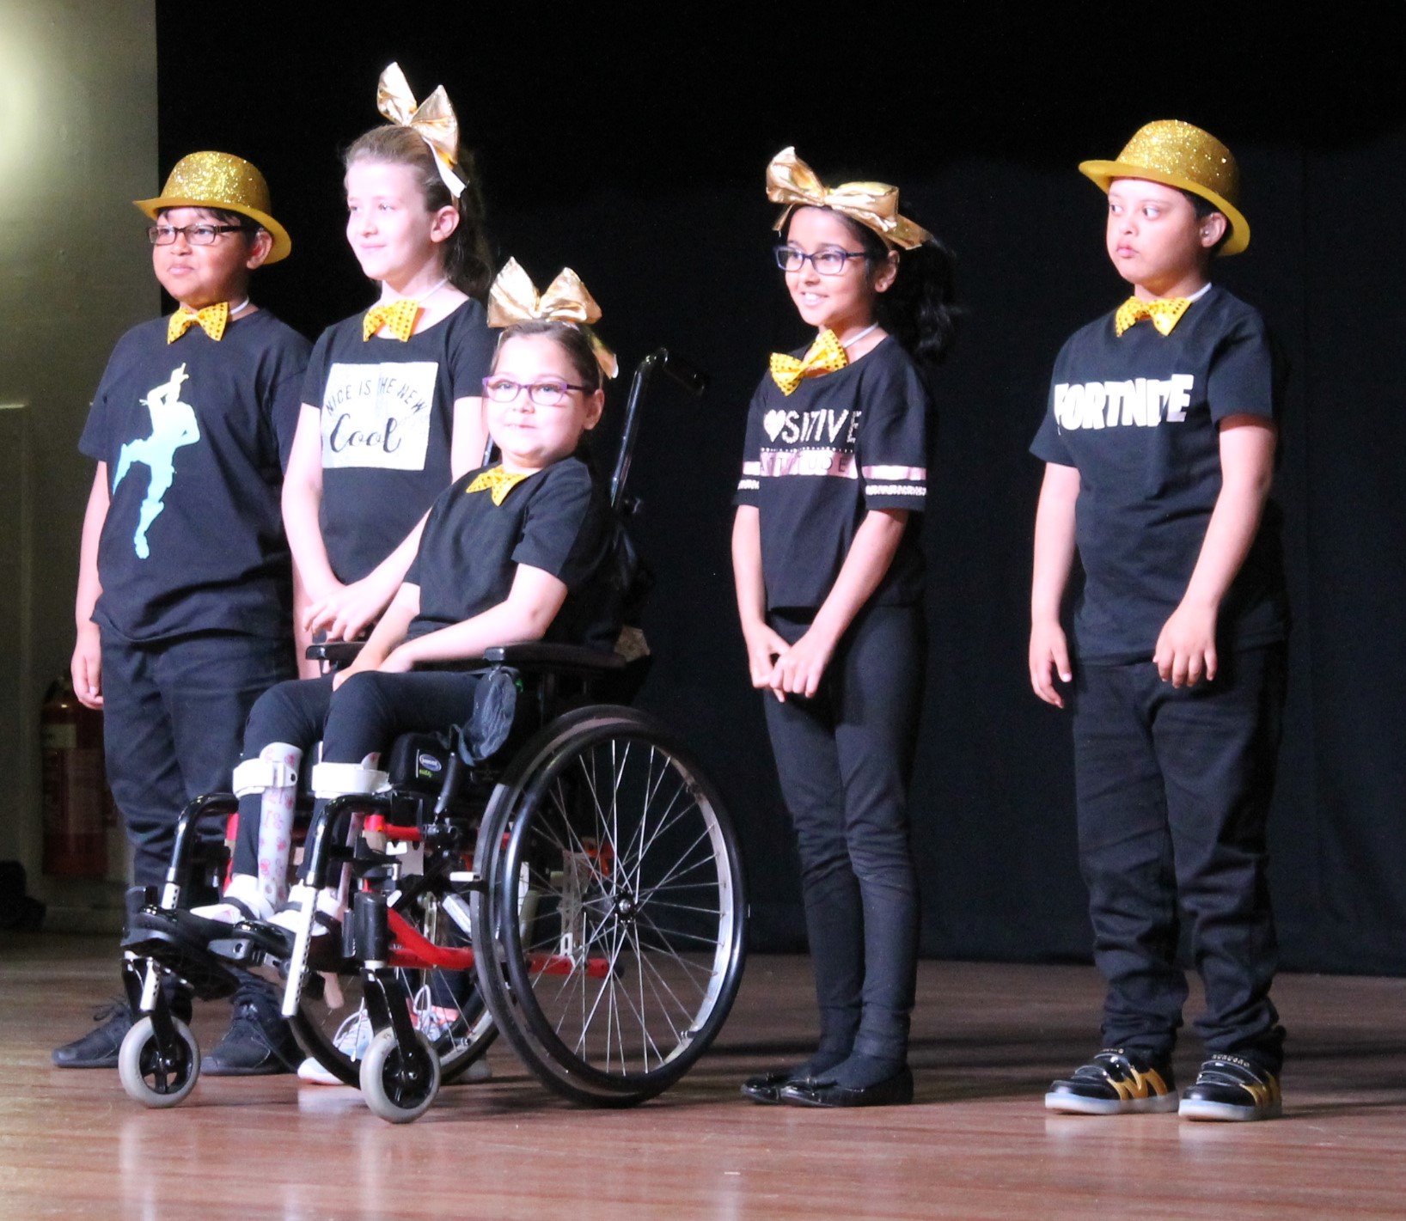

Parent Support

At Roding we see our partnership with our parents as an important part of our children’s progress. By working together we can achieve the best for all our children. Parents are invited to all annual reviews and progress meetings in addition to parents evening. We use Edukey to communicate with families regularly. Parents are invited to events with the NDCS and are encouraged to attend all school events.

